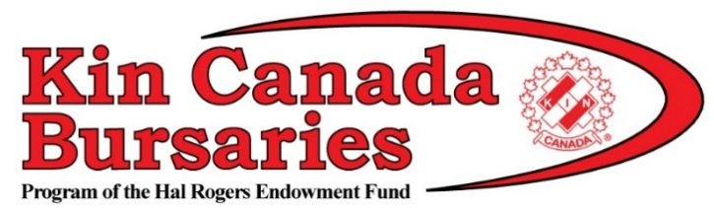

SAMPLE MEDIA RELEASE TO PROMOTE YOUR CLUB

For Immediate Release

< Club Name >
is now accepting student applications
for post-secondary funding

CITY, PROV (Month, Year) – The __________ Club of ___________ is proud to offer a chance for local students, studying at the post-secondary level, to apply for a Kin Canada Bursary.

Students attending a recognized post-secondary institution during the 2018-19 school year are encouraged to apply for a $1,000 bursary. Applications will be accepted until February 1, 2018 and can be downloaded at www.kincanada.ca/bursaries.

Bursaries are awarded to students based on financial need, community and school involvement, and knowledge of Kin Canada. Successful applicants will be notified in June 2018.

Kin Canada Bursaries is a program of the Hal Rogers Endowment Fund. Hal Rogers, Kin Canada’s founder, was a passionate advocator of educating Canada’s youth.

Since Kin Canada Bursaries was established in 1994, almost a million dollars in bursaries have been awarded to students pursuing post-secondary education. The bursaries are supported each year by the fundraising efforts of Kinsmen, Kinette and Kin Clubs across the country. Clubs work to better their communities and enhance the well-being of Canadians. The Association boasts a proud 95-year history dedicated to fostering lifelong friendships while ‘Serving the Community’s Greatest Need’. For more information about Kin Canada, visit www.kincanada.ca.

For more information, please contact:

(Insert name of club contact person), with the (insert name of club)
Phone: _________________________
Email: __________________________

###

